**Shell Script Assignment**

**1. Create a script named “myscript” in current directory to do the following.**

**a) display “hello user”**

**b) list files in current directory**

**c) name of logged in user**

**d) date**

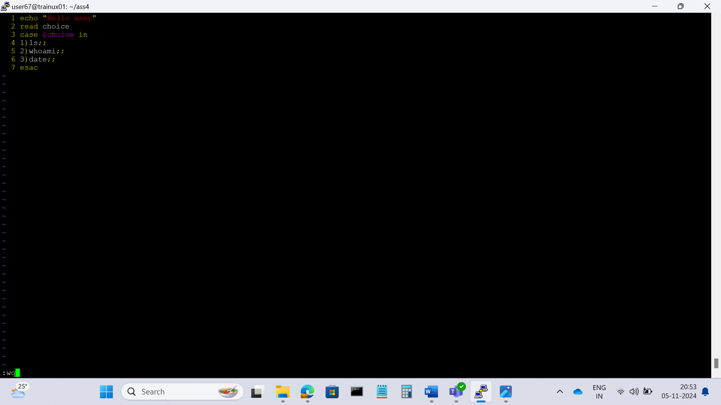

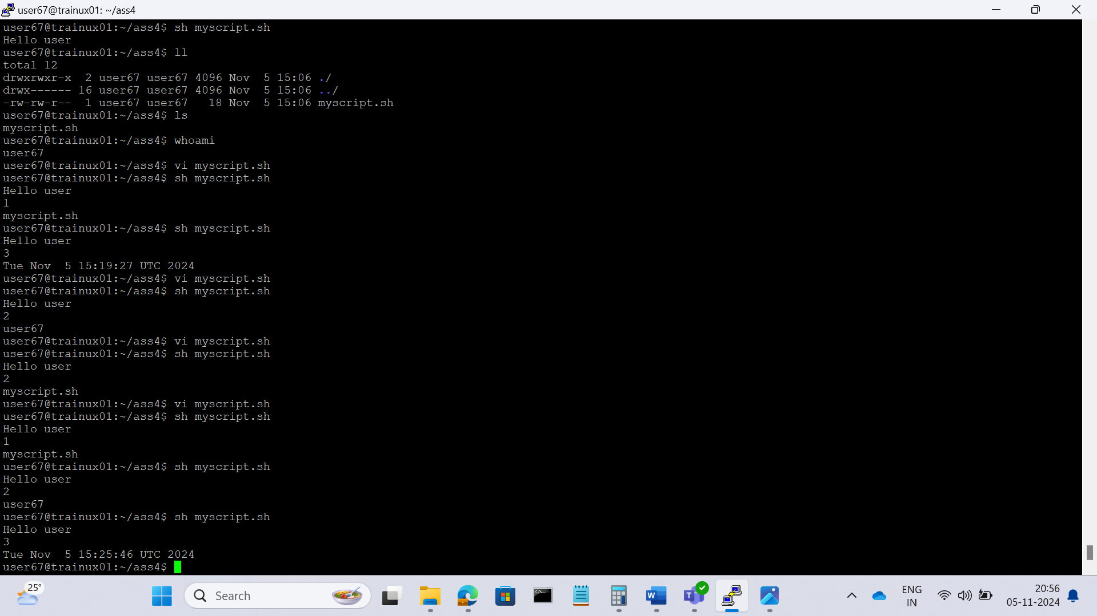

**2. Add execute permission and Run the script from**

**a) current directory**

A. chmod a+x myscript.sh

**3. Create a subdirectory named “test”**

A. mkdir test

**4. Change to “test” directory. Run the script “myscript” [Hint: You will have to update PATH to include the directory containg script to run script from any location].**

A. cd test

sh <path of myscript.sh>